ENGR 12 Assignment 11 Due: next wed
Part I. Drills -- 1 point each
- Use Freemat to solve the following system of equations for I1 and I2 (answer in rectangular form):

(27 + 16j ) I1 — (26 + 13j) I2 = 0
(13 – 14j) I1 — (12 – 16j) I2 = 150

- Find the Thevenin Eq for this Norton and the Norton for this Thevenin
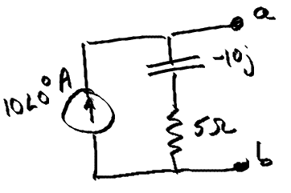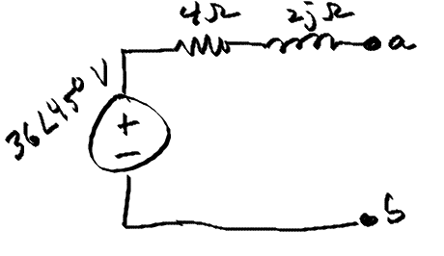
- Find v1(t) using Nodal Analysis 4) Use Mesh Analysis to find i(t)
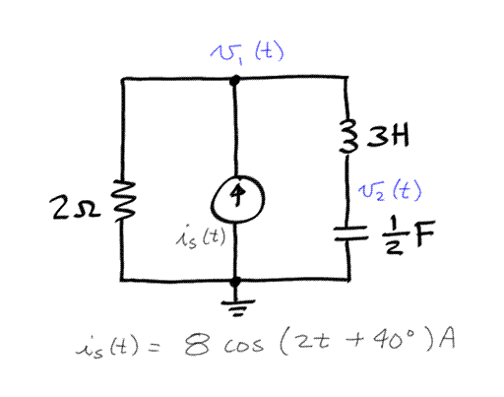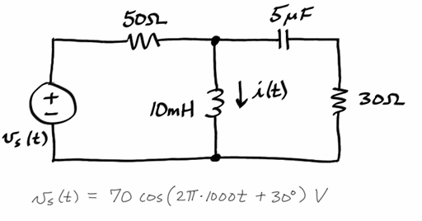

- Find the Thevenin Equivalent at a-b:
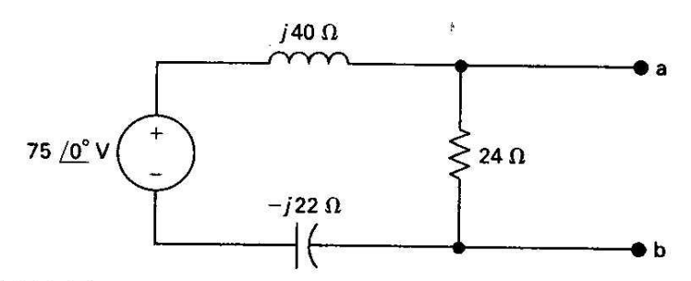

Part II. Assisted Problem Solving – 2 pts
6) Find Vx in phasor form using the mesh current method | Plan  - Note the arbitrary direction of the mesh currents, be careful when deriving mesh equations.  - Using I3 as shown, Vx = 10(I3)  - Use matlab/freemat to solve the set of equations  - Check your answer by verifying KVL around the perimeter of the circuit
7) Use Node Voltage to find I in the circuit below  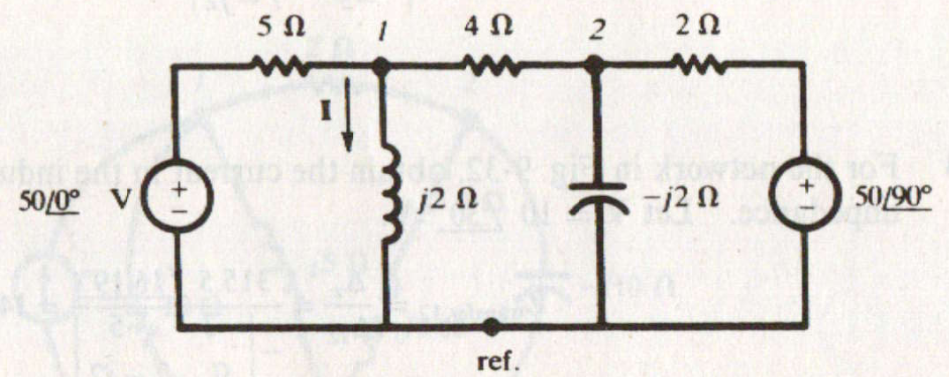 | PLAN  - Use ref. as the ground node  - Use freemat/matlab to solve equations  - Check your answer by verifying KCL at node 1
Part III. Unassisted Problem Solving – 3 points
8) Find the Thevenin equivalent of the circuit at a-b.
