ENGR 12 Assignment 3 Due: next wed
Part I. Drills -- 1 point each
Find the equivalent resistance measured at terminals a and b. Remember all currents in a series path are the same. All voltages across parallel paths are the same.
- 2) 3)
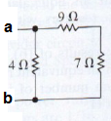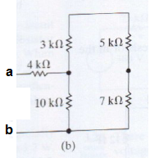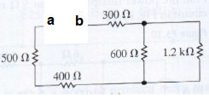
- Use voltage division to find the voltages v0 and v1
- This is Prob 2.27 in your text b) Note V1 is measured across the 36||12 combination
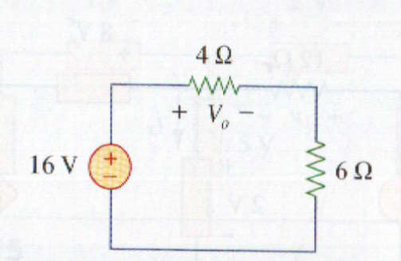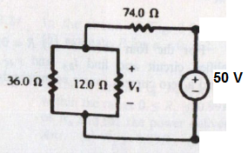

- Find the current i using current division
  - i is current thru series 6+5 Ohm branch b. This is two cascaded current dividers
Find Req to right of 10 ohm resistor and do divider A
Then divide again at B between the 5 and (8+12) paths
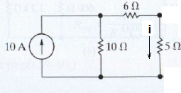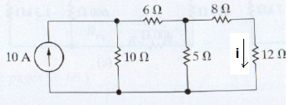

- Convert the Wye to Delta and the Delta to Wye
  - this is 2.48a b. this is 2.49a

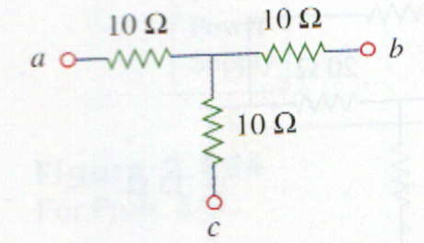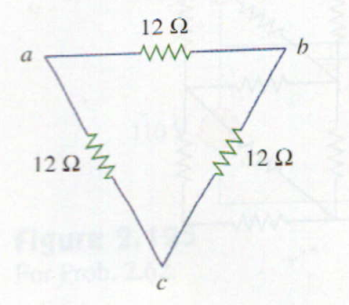

Part II. Assisted Problem Solving – 2 pts each
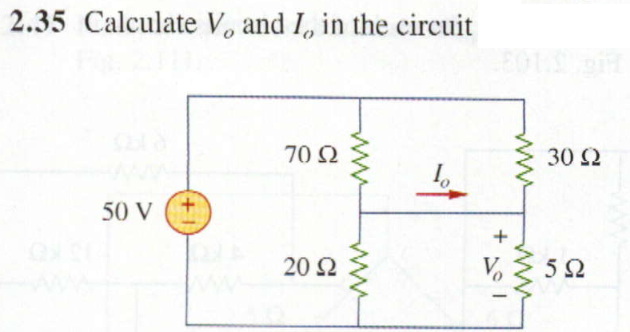 | HINTS  - The wire across the middle is one large node  - There is one parallel path from top to middle  - and another parallel path from middle to bottom  - Find Req for (2) and (3), then use voltage divider to find Vo  - Find currents in all four resistors and use KCL to find Io
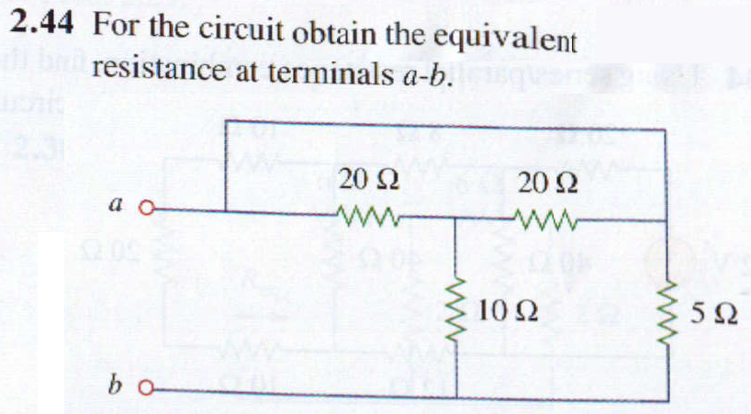 | HINTS  - Converting Wye to Delta is ONE way to solve this – then deal with the short across top using parallel resistor formula ( using R=0 for the short)  - A more elegant way is to morph the circuit, collapse the short from (a) to 5 Ohm into one node at top, with 2 parallel 20 Ohms connecting to a series 10 and the whole thing parallel to 5…can you see it? Be careful while morphing not to change the circuit!

Part III. Unassisted Problem Solving – 3 points each
9) Find V in the following circuit
