ENGR 12 Assignment 4 Due: next wed
Part I. Drills -- 1 point each
- Find V1 and V2 using Node Voltage  (V₁ = -20 V, V₂ = -40 V)  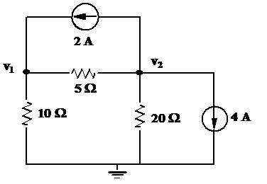  - Find V2 and V3 using the Node Voltage Method (V1 = 12V)  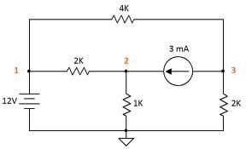  - 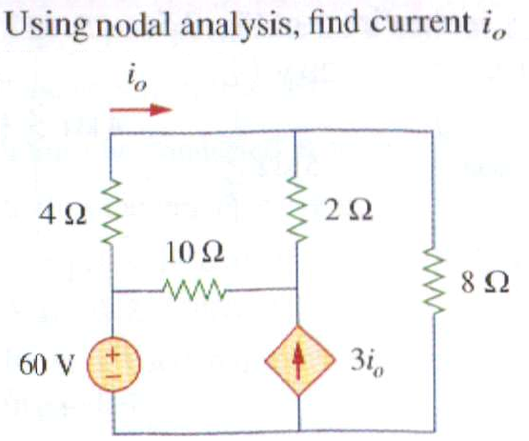 | - Find I1 and I2 using Mesh Current  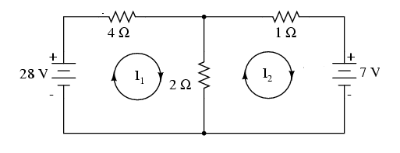  - Use Mesh Analysis to find vo  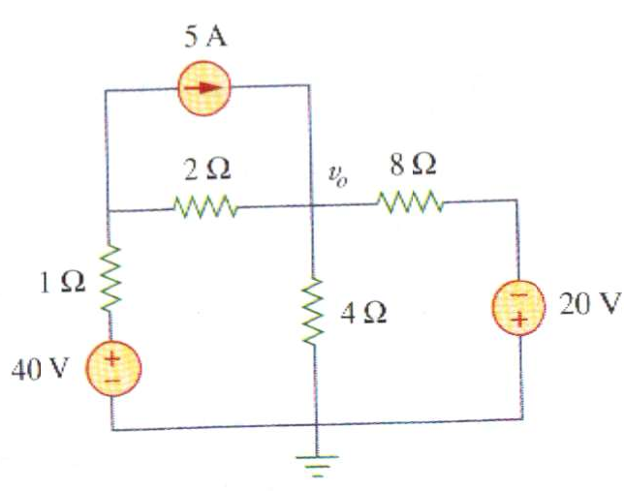  - Solve for I1, I2 and I3 using Mesh Analysis  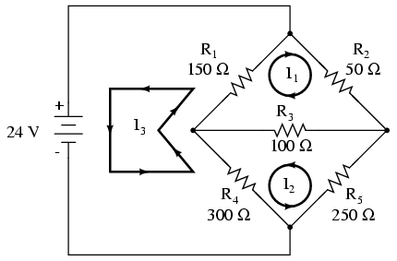

Part II. Assisted Problem Solving – 2 pts each
6 Solve for Ix using the NV method (SuperNode)  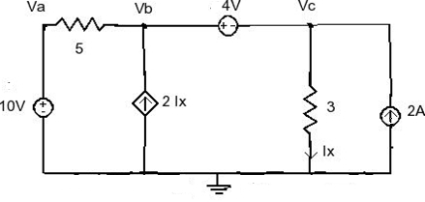 | PLAN  - Va is known at _____ volts  - Vb/Vc form a supernode. Write the node equation for the supernode in terms of Vb, Vc and the two current sources.  - Determine ix in terms of Vc and the 3 Ohm resistor  - substitute ix out of your answer for (2)  - Use KVL to relate Vb, Vc and the 4V source  - Solve two equations (4) and (5) for Vb, Vc  - Calculate ix using (3)
7 Use the Mesh Current “SuperMesh” technique to find Vx, the voltage across the 5A current source  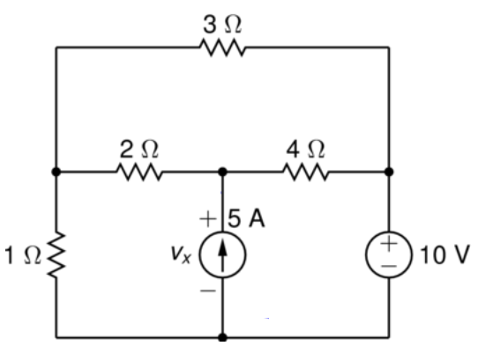 | PLAN  - label meshes ia (top), ib (left), ic (right)  - write the mesh eqn for ia  - write the mesh eqn for supermesh ib/ic  - use kcl to relate ib, ic and the 5A source  - solve equations using matlab/freemat  - determine the branch current thru the 2Ohm resistor, i2, and the current thru the 1 ohm resistor i1  - using i1, i2 and KVL, determine Vx
Part III. Unassisted Problem Solving – 3 points each
8) Use either NV or MC to solve for vx
