ENGR 12 Assignment 6 Due: next wed
Part I. Drills -- 1 point each
- For the following circuit: What type of Op-Amp circuit is it? ________________ then, find V1 and V2
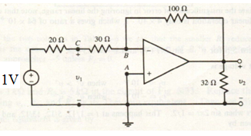
- For the following circuit: What type of Op-Amp circuit is it? ________________ then, find Vo
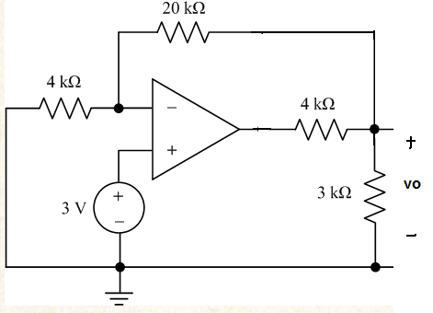
- For the following circuit: What type of Op-Amp circuit is it? ________________ then, find Vo
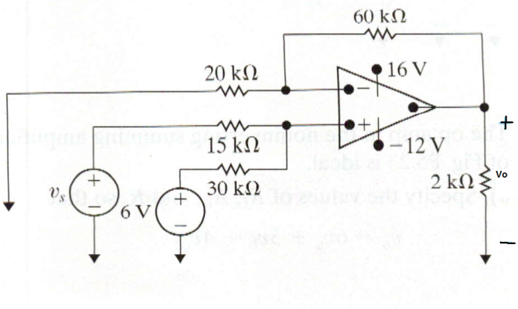

- For the following circuit: What type of Op-Amp circuit is it? ________________ then, find iL in micro-Amperes
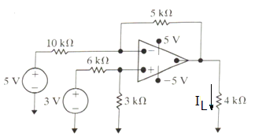

- Repeat #1 using non-ideal op-amp model. Take A = 100000, Ri = 500 kOhm, Ro = 75 Ohm [ a CHALLENGE!!!]
See Lecture Slide 6 for details. Set up non-ideal model in prob1 circuit and perform KCL/KVL to determine Vo.
Part II. Assisted Problem Solving – 2 pts each
6 Find Vc, i1, Rin (input Resistance seen by 9V source), v2, i2  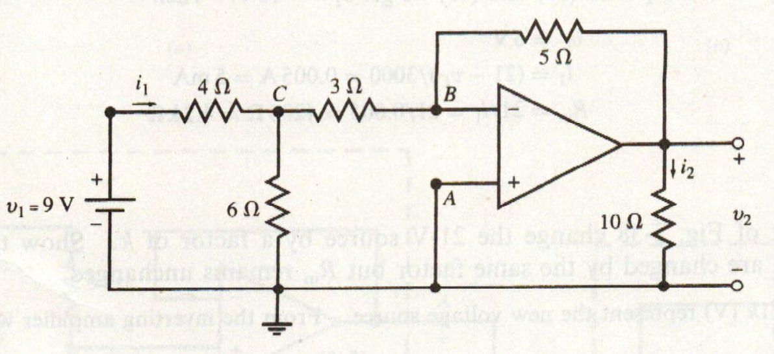 | PLAN  - Observe that VB = 0 due to negative feedback  - Set up a Node equation for Node C, find Vc  - Use Vc to find i1  - Rin is just V1/i1  - use the appropriate amplifier formula to find v2  - and so find i2
7 Find Vo for the following 2 stage amplifier. What is the total gain of the amplifier? (G = vo/Vin)  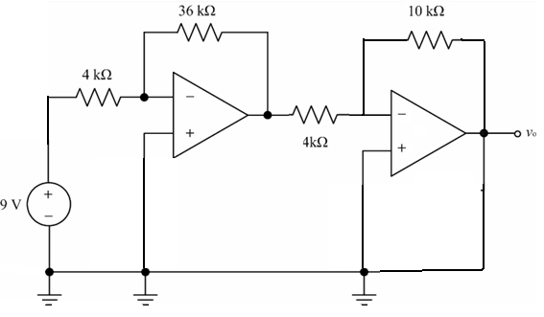 | PLAN  - First identify the types of amplifier circuits being employed for both op-amps.  - Using the appropriate amplifier formula, find the output of the first op-amp.  - Use this result in another op-amp formula to determine Vo  - Use this result in the Gain formula
Part III. Unassisted Problem Solving – 3 points each
8) Find vo for the following circuit:
