Datasheet for Lab 11: Phasors and MATLAB
Name(s): _______________________ Date: ________________________
Approximate Time To Complete (in hours)______________________
Prelab: Watch the video overview and in-lab questions for this lab
Part 1: Complex Numbers and MATLAB / FreeMat

Given that we have four complex numbers, some in rectangular form others in polar form:
a = 3 + 4i
b= -5 + 6i
c = 8<45 (This means a magnitude of 8 and an agle of 45 degrees)
d = 12<250
Use Matlab or FreeMat to compute the following (enter your final answers in the space provided)

- Express these quantities in rectangular form:

Quantity | MATLAB Command(s) you typed | Numeric Result
a + b
a/b
c
c + d

- Express these quantities in polar form (magnitude and phase):

Quantity | MATLAB Command(s) you typed | Numeric Result
a
c/d
ab
a + c

Part 2: Phasor Transforms
First verify the solution to (a) in both problems below, then use MATLAB or FreeMat to find answers to the other questions:

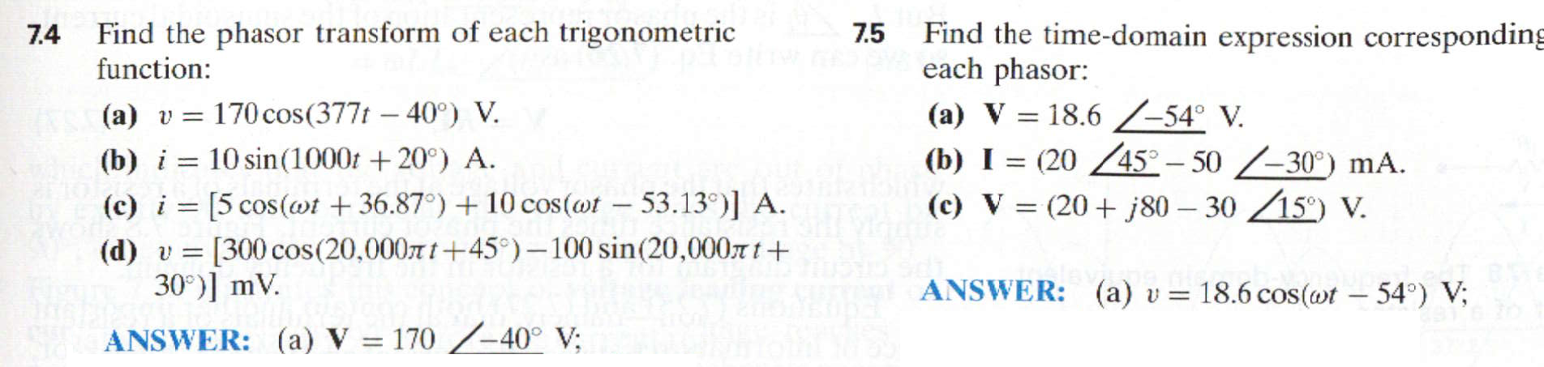
Answers
7.4 b) | 7.5 b)
7.4 c) | 7.5 c)
  - d)

Part 3. Basic Circuit Elements in the AC (Phasor) Domain
We sometimes refer to the impedance of a capacitor or inductor as Zc or ZL. Find Zc and ZL for the circuit shown. Assume the vin(t) is a 60 Hz sinewave, in which case the angular frequency ω = 2πf , which is ~377 radians/sec.
Quantity | MATLAB Command(s) you typed | Numeric Result
w
ZC
ZL
Phasor Transform of Vin

Part 4. AC Solution by Phasor Analysis (assume f still = 60 Hz)

Solve for phasor Vout in the example problem. Use values for Vin, ZL, and ZC that you calculated in Part 3.

Quantity | MATLAB Command(s) you typed | Numeric Result
Vout (phasor)
vout (time
domain)

Exercises

2. Calculate v(t) by first translating the circuit into the phasor domain, solving for the answer, then converting back into the time domain.

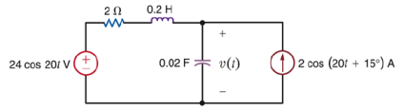

3. Calculate v_{x}(t) by first translating the circuit into the phasor domain, solving for the answer, then converting back into the time domain.

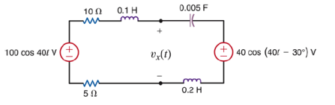

When you are finished, please estimate the number of hours it took you to complete this lab and enter at the top of this datasheet.

